# Front-End UI/UX Mini Project

Project Title: "Tech Innovators Conference 2025"

Submitted By:  
 Team Members – Chris Kevin A – 2460349

Patrick Kevin – 2460419

Kavin M - 2460391

College – [chris.kevina@bteach.christuniversity.in](mailto:chris.kevina@bteach.christuniversity.in)

[patrick.kevin@btech.christuniversity.in](mailto:patrick.kevin@btech.christuniversity.in)

[kavin.m@btech.christuniversity.in](mailto:kavin.m@btech.christuniversity.in)

Course: UI/UX Design Fundamentals

Instructor Name: Swathi

Institution: Christ University

Date of Submission13/08/2025

# 1. Abstract

This project aims to design and develop an event website for the Tech Innovators Conference 2025 using only HTML and CSS. The website highlights event details such as the date, location, agenda, speakers, ticket pricing, and venue information. It also includes an online registration form and a confirmation page to acknowledge successful registrations. The design focuses on a clean and responsive layout, organized content sections, and a visually appealing presentation that enhances the event's professional image.

# 2. Objectives

• Design a user-friendly interface following modern UI/UX principles to ensure intuitive navigation and engaging visual appeal.

• Develop a fully responsive layout using only HTML and CSS, ensuring compatibility with desktops, tablets, and mobile devices.

• Implement structured HTML5 semantic elements for improved accessibility, SEO optimization, and maintainable code.

• Apply CSS styling to establish consistent branding, manage layout structure, and adapt to various screen sizes.

• Ensure accessibility and readability by using proper color contrast, readable typography, and mobile-friendly design techniques.

# 3. Scope of the Project

The Tech Innovators Conference 2025 project focuses solely on front-end web design, creating a visually appealing and informative event website. Development is limited to HTML and CSS, with no JavaScript or server-side functionality implemented. The website is designed to be fully responsive, ensuring optimal viewing on desktop, tablet, and mobile devices. The scope includes structured HTML5 coding, CSS-based layout design, responsive styling, and accessibility considerations, while excluding backend features such as databases, authentication, or content management systems.

# 4. Tools & Technologies Used

|  |  |
| --- | --- |
| Tool/Technology | Purpose |
| HTML5 | Markup and content structure |
| CSS3 | Styling and layout management |
| VS Code | Code editor |
| Chrome | Testing and debugging |

# 5. HTML Structure Overview

The Tech Innovators Conference 2025 website is built using HTML5 semantic tags such as <header>, <section>, and <footer> to ensure clarity, accessibility, and SEO friendliness. The structure is organized into reusable content sections, including:

• Hero Section – Displays the event name, date, location, and a 'Register Now' button.

• Speakers – Introduces keynote speakers with photos and designations.

• Agenda – Lists the schedule of events across three days.

• Tickets – Shows ticket pricing and a registration link.

• Venue – Displays venue information and an image.

• Footer – Contains copyright and sponsor logos.

• Registration Form – Collects participant details and submits to the confirmation page.

• Confirmation Page – Acknowledges successful registration.

# 6. CSS Styling Strategy

The website uses separate CSS files for the home page and the registration/confirmation pages to control design, layout, and responsiveness. The CSS is organized into logical sections for typography, colors, and structure.

• Flexbox and Grid for arranging sections and responsive speaker cards.

• Media Queries to ensure responsiveness across devices.

• Consistent color palette for branding and readability.

• Hover effects on buttons and speaker cards to enhance interactivity.

• Background images for hero and form sections to improve visual appeal.

# 7. Key Features

|  |  |
| --- | --- |
| Feature | Description |
| Responsive design | Adapts seamlessly to all screen sizes |
| Smooth Navigation | Direct links to registration form and sections |
| Speaker Grid | Image cards with hover effects |
| Registration Form | HTML form with required fields and pattern validation |
| Accessible Fonts & Colors | High contrast and readable typography |

# 8. Challenges Faced & Solutions

|  |  |
| --- | --- |
| Challenge | Solution |
| Responsive image scaling | Used max-width and height auto for all images |
| Form alignment on small screens | Applied media queries to adjust padding and width |
| Maintaining consistent styling | Used shared CSS classes for repeated elements |

# 9. Outcome

The project successfully delivered a clean, responsive, and visually appealing front-end layout for the Tech Innovators Conference 2025. It includes a hero section, speakers grid, agenda, ticket details, venue info, registration form, and confirmation page. The website adapts well to different devices and screen sizes while maintaining branding consistency and accessibility.

# 10. Future Enhancements

• Add JavaScript for form validation and interactive content updates.

• Integrate animations for smooth transitions and hover effects.

• Backend integration to store registrations and send email confirmations.

• Theme toggler (light/dark mode) for accessibility and personalization.

# 11. Sample code

# Sample: Section-based Layout HTML

html

Copy

Edit

<!-- Hero -->

<header class="hero">

<h1>Tech Innovators Conference 2025</h1>

<p>March 15-17, 2025 | Bangalore, India</p>

<a href="#tickets" class="btn">Register Now</a>

</header>

<!-- Speakers -->

<section class="speakers">

<article class="speaker-card">

<img src="https://randomuser.me/api/portraits/women/44.jpg">

<h3>Jane Doe</h3>

<p>AI Researcher</p>

</article>..

</section>

# Sample: Responsive Grid Layout CSS

css

Copy

Edit

.speakers {

display: grid;

grid-template-columns: repeat(auto-fill, minmax(220px, 1fr));

gap: 20px;

}

.speaker-card {

background: #f5f5f5;

padding: 15px;

border-radius: 8px;

text-align: center;

transition: transform 0.3s;

}

.speaker-card:hover {

transform: translateY(-5px);

}

# 12.Screenshot of Final Output



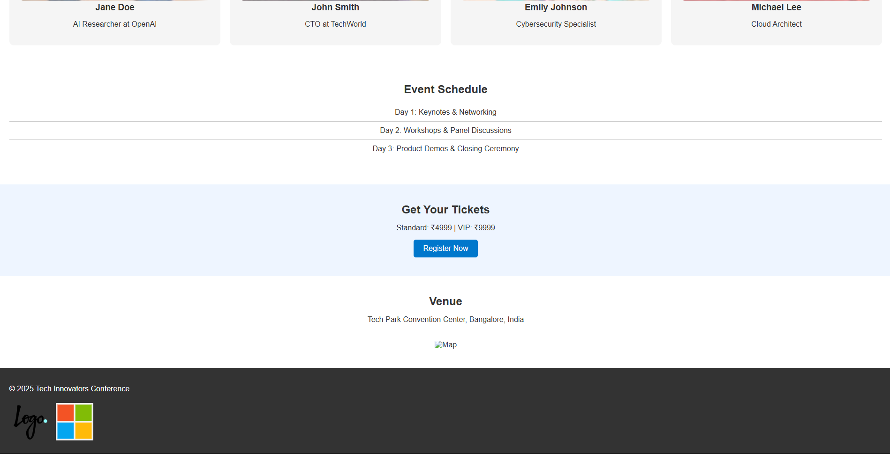

# 13. Conclusion

The Tech Innovators Conference 2025 website is a static HTML and CSS project that provides essential event information and allows participants to register online. It follows responsive design principles, ensuring usability across devices. This project enhanced skills in semantic HTML structuring, CSS styling, and UI/UX best practices.

# 14. References

• L&T LMS: https://learn.lntedutech.com/Landing/MyCourse